**BEY444E. GRADUATION THESIS GUIDELINES**

**Purpose**

The purpose of this guide is to determine the rules that will enable the integrity, layout , evaluation and grading of the Graduation Thesis assigned to the English Programe of Nutrition and Dietetics with the lecture code of BEY444E

**Graduation Thesis Subject and General Principles**

Graduation thesis can be done in review or research type. The aim of the review type graduation thesis is to present an explanatory compilation text that does not have a theoretical purpose, by doing a current source research on a subject covering the literature. In the research type graduation thesis, the aim is to carry out a basic research on an original subject and to present the results with a text that explains.

**Duties of Supervisor**

The advisor is responsible for supervising the originality requirements of the thesis topic, guiding the preparation of the thesis proposal, guiding in obtaining ethics committee approval when necessary, supervising the thesis writing process and ensuring that the thesis writing guide is followed. The thesis advisor conducts regular meetings with the student in order to evaluate the thesis writing process and status, and documents these interviews in return for the participant's signature (ANNEX-2). The thesis advisor is responsible for scoring the thesis by obtaining the signature of the student who has delivered the thesis (ANNEX-3). In this respect, the student is expected to share the progress with the thesis advisor at regular intervals and document these interviews.

The student has to submit his/her thesis to his/her advisor 7 working days before the final exams in the academic calendar. The thesis advisor has to send the thesis and similarity report electronically to the department chair during the week of the final exams, and submit the ANNEX-1, ANNEX-2, and ANNEX-3 forms to the department chair as a print out with a wet signature.

**General Guidelines:**

1. The thesis should be at least 30 pages, excluding the references section, and at least 20 different current sources should be used.
2. Compliance with the general grammar, punctuation and spelling rules of the language in which the thesis is written is required.
3. Punctuation and spelling arrangements should be used correctly in the writing of the graduation thesis and the units should be given in accordance with the International System of Units (SI).
4. There should be unity in terms used in thesis. (For example, whichever of the terms having the same meanings as 'part'/'section', 'law'/'regulation', 'theory'/'hypothesis' is preferred in the thesis text, that term should be used with the same meaning throughout the thesis.
5. Style unity should be ensured in thesis.
6. Quotations or quotations from one or more sources in theses should not be given one page or more one after the other. The sentences in the text should NOT be taken directly from the source they use and should not be placed in the text directly through copy and paste or by simply been writen directly. Instead, criticism, comments or explanations of the author of the thesis should be included among the quotations/citations.
7. Scientific and ethical rules must be strictly obeyed.
8. A plagiarism report should be received after dissertation. The plagiarism rate must be below 20% (except bibliography). The similarity rate from one source should not be more than 2%. The similarity rate should be entered in the relevant place in the thesis introduction form on the first page of the thesis.
9. In the writing, an effort should be made to follow a clear and simple style of expression, and the narration should be done in the passive third person singular. Short, simple and concise sentences should be used, care should be taken to ensure that there is a unity of ideas in the paragraphs and to establish the necessary expressive connections between paragraphs and transitions from chapter to chapter.

**LAYOUT CHARACTERISTICS OF THE THESIS**

In this section, the issues such as paper features, page layout, page numbering, writing features, spelling, paragraph, citations, quotations, footnotes, location of the visual objects, etc. are explained.

“The formal rules related to the thesis writing” and the settings stated in the “rules of thesis writing in this Section are Microsoft Word’s word processing settings. On condition that the student is close to these standards, he /she can use the word processing program he/she wants.

**1.PAPER FEATURES AND PRINTING**

Thesis are written on the computer, printed. In writing the thesis, 21x29,7 cm (A4) page size, in printing, at least 80 grams of first pulp white paper in the same size is used. The paper size can be changed with the approval of the thesis supervisor in such cases as when the writing field requires for various table, figure, graphic, picture, map, etc. However, these papers in different dimensions should be folded appropriately in binding. One side of the paper is used in printing and reproducing the thesis.

Fort his reason a margin of 4 cm is left on the left edge of the page and 2.5 cm is left on the other edges. The outer cover, blank page, thesis presentation form, inner cover page are not numbered.

**2.FONT SIZE**

The general body of the thesis is written in Times New Roman, in 12 font size, 1,5 line spacing, with vertical and normal letters, with left and right alignments. When necessary, bold or italic style can be used. In tables and figures, if necessary, it can be minimized to 8 font size. The symbols used in the thesis are created in computer environment without any character limitation with regard to the formulas. In writing equation or formula, “Equation” is chosen from “Insert” menu of MS Word and it can be created as given in the example below. For each created equation, number is given consecutively.

**Paragraph Structure And Line Spacing:** Paragraphs start 1 cm from the left. There is 1.5 line spacing between lines.

Paragraph structure using the format toolbar for this;

Alignment: Justify,

Indent (left and right): 0 cm

Indent (custom): The first line is selected and the value is set to 1 cm.

Interval (before and after): 6 pt

Line spacing: 1.5 lines.

**3.FONT OF THE HEADING AND FONT OF THE COVER PAGE:**  For the title of the thesis, Times New Roman 16, Times New Roman 14 font and size bold letters are used for the titles. These spellings are automatically adjusted in the "introduction" "styles" section in the Word tab in the thesis template.

**4.TITLE AND SUBHEADINGS**: All headings in the text should be in given bold. Section Headings should be in Times New Roman 14 points, all capitals and bold, centered on the page. Second-level section headings should be 12 points, the first letter of each word should be capitalized and bold, in line with the beginning of the paragraph. Section headings at the third and fourth level should be 12 points, the first letters are capitalized and bold, in line with the beginning of the paragraph.

**5. PAGE NUMBERS SHOULD BE PLACED AT THE BOTTOM OF THE PAGE AND IN THE MIDDLE:** Page numbers should be centered and given at the bottom of the page. At the beginning of the thesis, which consists of a summary, abstract, preface or acknowledgment, table of contents, list of tables, list of figures and abbreviations, lowercase Roman numerals (i, ii, iii, iv. v ....); Normal numbers (1, 2 ..) should be used in the text section consisting of the introduction, other sections, conclusion and/or discussion, references and appendices. Numbers should be written in Times New Roman 11 points. The same numbering system should be used throughout the thesis. Before and after the page numbers, separators, dashes, etc. characters should not be used.

**6.TABLES;** It consists of four main elements: number and title, frame, content and footnotes. All tables in the text are numbered (Table 1) and tables are referenced according to this number. Tables should be numbered sequentially from beginning to end. Numbering of tables is Times New Roman, 12 pt, bold font; “Table 1.” form should be made. Table 1. The first letter of the title that comes after the number is written in lowercase, provided that it is capitalized. While creating the table, the same and similar data should not be presented in more than one table, and a table should not be prepared for data that can be summarized in a sentence or two. The information remaining in the table (column, header and data) constitutes the content of the table. Column headings and table data are written centered. Font size can be adjusted according to the table, but should not be less than 8 points. Explanations of the table data and the source are explained in the footnote of the table. Where the data in the table is obtained from, even if the author calculated or produced it himself, the source should be cited in the footnote of the table.

***Table 1. Westerlund Comparison of the Late Delays***

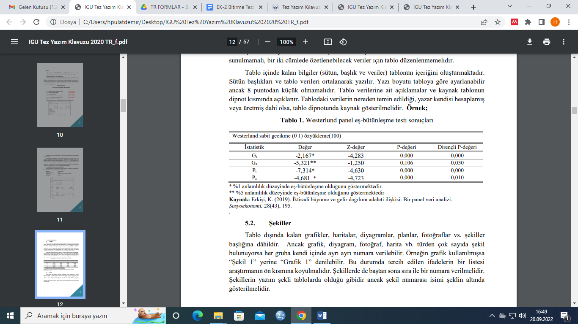

**7. FIGURES AND GRAPHICS:** Graphs, maps, diagrams, plans, photographs, etc., (anything other than tables) are included in the figures. But graphics, diagrams, photographs, maps, etc. can vary. If there are many shapes of this type, each group can be numbered separately. For example, if a graphic is used, "Graph 1" can be said instead of "Figure 1". In this case, a list of preferred expressions should be placed at the Figures Table given in page iv. Figures should also be numbered sequentially from beginning to end. The spelling of the figures is the same as in the tables, but the figure number name should be shown below the figure.

metin içeren bir resim

Açıklama otomatik olarak oluşturuldu

**Figure 1. Display of the Allignment of the text from Word**

**8.Equations:** Equations should be placed closest to where they are mentioned in the text and should be written legibly and clearly through an equation editor package.

metin içeren bir resim

Açıklama otomatik olarak oluşturuldu

**Figure 2. Adding Equation**

**9.CITATION RULES**

In this section, how in-text citations and quotations should be made is explained in detail, how a reference section can be created is emphasized and reference components such as author, date of publication, editor and publisher are referred. While making citation, APA-American Psycho-logical Association should be used.

# APA Citation Style Guide, 6th ed.

Developed by the American Psychological Association, this style is widely used in the sciences and social sciences.

Each citation consists of two parts: the *in text citation*, which provides brief identifying information within the text, and the *reference list* (list of sources used) which provides full bibliographic information.

# How to Format In Text Citations

(For more detailed information see Publication Manual Chapter 6, pp 174-179)

APA Style gives prominence to the date of a publication. In-text citations use the author's last name and the date, separated by a comma, as a brief reference in the text of the article to refer the reader to complete information in the reference list.

(Austin, 1998)

**If the author's name is mentioned in the narrative**, then only the date need be given:

Austin (1998) compared institutional support

**Two authors**. Always use both names every time they are referred to in the text. Use the ampersand (&) to connect the names in the parentheses, but spell out "and" in the running text.

(Parker & Mokhesi-Parker, 1998)

Parker and Mokhesi-Parker (1998) in examining institutional design and function …

**Three to five authors**. Cite all the authors in text the first time a reference occurs; in subsequent citations, include only the surname of the first author followed by et al.

First reference:

(Parker, Mokhesi-Parker, AuthorC, AuthorD & AuthorE, 1998)

Subsequent references:

(Parker et al.)

**Six or more authors**. Cite in text only the surname of the first author followed by et al. and the year for the first and subsequent citations.

(Parker et al., 1998)

**Group or corporate authors**. Use the name of the body in the citation:

(World Bank, 1998)

**Unknown author**. Use the first few words of the title as the reference in the text (capitalize all words in title):

("Structuring Lawmaking", 2002)

**Author is listed as "Anonymous"**. Use it as if it were the author's name.

(Anonymous, 2003)

**When paraphrasing**, APA style does not require page numbers in the in-text citation. However, authors are encouraged to include page numbers if it will help the reader locate the relevant information in longer texts. Consult with your professor regarding the need for page numbers for paraphrased information.

**If the reference is to an exact quotation**, the author, year and page number must be included. The page number can be given in parentheses at the end of the exact quotation or incorporated into the in-text citation.

Newman (1994) concluded "sibling conflict is so common that its occurence is taken for granted" (p. 123).

Such findings have prompted one researcher to conclude, “Sibling conflict is so common that its occurrence is taken for granted” (Newman, 1994, p. 123).

**For exact quotations from sources without page numbers**, use paragraph numbers, if available. If the paragraphs are not numbered, but there are headings, use the heading name and count the number of paragraphs after the heading to the paragraph containing the quotation. (Publication Manual, Chapter 6.05, p. 171)

(Smith, 2003, para. 1)

(Greene, 2003, Discussion, para. 4)

**For citations taken from secondary sources**, include the secondary source in the reference list and mention the original work in the text.

Text citation:

Goldman and Goldman's study (as cited in Linebarger, 2001) found ....

Reference List:

Linebarger, D. L. (2001). Learning to read from television: The effects of using captions and narration. *Journal of Educational Psychology, 93*(2), 288-298.

|  |  |
| --- | --- |
| **journal (one author)** | rappers, 1992-2000. *Journal of Black Studies*, *39*(5), 786-802. doi:10.1177/0021934707302454 |
| **Article in a journal (up to seven authors)** | . H., Yen, J. Y., Liua, S. C., Huanga, C. F., & Yen, C. F. (2009). The associations between aggressive behaviors and internet addiction and online activities in adolescents. *Journal of Adolescent Health, 6,* 598-605. doi:10.1016/j.jadohealth.2008.11.011 |
| **Article in a journal (more than seven authors)** | er, J., Gochfeld, M., Jeitner, C., Burke, S., Stamm, T., Snigaroff, R., ... Weston, J. (2007). Mercury levels and potential risk from subsistence foods from the Aleutians. *Science of The Total Environment, 384,* 93-105. doi:10.1016/j.scitotenv.2007.05.004  When authors number eight or more, include the first six names, then three ellipses, and then the last author's name. (Publication Manual, Chapter 7.01.2) |
| **Article in a journal (advanced**  **publication)** | kaya, A., Weiner, O. D., Lim, W. A., & Voigt, C. A. (2009). Spatiotemporal control of cell signalling using a light-switchable protein interaction. *Nature*. Advance online publication. doi:10.1038/nature08446 |
| **Online-only supplemental material for articles** | dler, D. (2009). Liquids: Condensed, disordered, and sometimes complex. [Supplemental material]. *PNAS: Proceedings of the National Academy of the United States of America, 106,* 15111–15112. doi:10.1073/pnas.0908029106  If no author is given, move the title and bracketed description to the author position. (Publication Manual, Chapter 7.01.15) |
| **Article in a popular**  **magazine** | y, W. A., III (1990, April 9). Beyond the melting pot. *Time, 135*(4), 28-31. |
| **Article in a newspaper** | g, J. (2003, February 14). Prozac campus: More students seek counseling and take psychiatric medication. *The Chronicle of Higher Education*, pp. A37-38.  If the article was found through the newspaper's website, include "Retrieved from" and the URL of the home page. (Publication Manual, 7.01.11) |

## Media

(Publication Manual, Chapter 7.07)

|  |  |
| --- | --- |
| **Music Score** | No example given in *APA Publication Manual* for music score. |
| **Sound Recording** | ond, P. (1959). Take five [recorded by Dave Brubeck Quartet]. On *Time out* [CD] New York, N.Y.: Columbia. (1987)  Use the original copyright date after the author/composer's name. If the date of the recording is different from the copyright date, place it after the name of the recording label, as above. (Publication Manual, 7.07) |
| **Video Recording** | o, G., & Brown, E. T. (Producers), & Cardozo, P. (Director). (2003). *Real womem have curves* [DVD]. United States: HBO Video. |
| **Television** | els, G. (Writer) & Kwapis, K. (Director). (2006). Gay witch hunt [Television series episode]. In G. Daniels (Executive producer), *The office*. Los Angeles, CA: National Broadcasting Company. |

## Web/Online

(Publication Manual, Chapter 7, pp 198-215)

**Note:** Different web browsers break the text in different places of a URL. In a printed work, if the URL needs to be broken at the end of a line, the break should be made after a colon or a double slash; before a single slash, a tilde, a period, a comma, a hyphen, an underline, a question mark, a number sign, or a percent symbol; or before or after an equals sign or an ampersand. ([CMS 14.2](http://www.chicagomanualofstyle.org/16/ch14/ch14_sec012.html))

|  |  |
| --- | --- |
| **Web page** | ers for Disease Control and Prevention. (2009). 2009 H1N1 Flu ("Swine Flu") and You. Retrieved from <http://www.cdc.gov/h1n1flu/qa.htm> |
| **Blog Post** | McAdoo, T. (2009, September 10). Use of First Person in APA Style [Web log message]. Retrieved from [http://blog.apastyle.org/.](http://blog.apastyle.org/)  In blog posts, authors may adopt a screen name. Use that screen name as the author if that is the name under which that person posts messages. |
| **Online Video** | ricks. (2008, April 27). Tips for training a parrot to talk [Video file]. Retrieved from  <http://www.youtube.com/watch?v=89dZNPPYOdk> |

|  |  |
| --- | --- |
|  | A screen name is used for the author name in this example. |
| **Data Sets** | university Consortium for Political and Social Research. (2007). *Eurobarometer 68.1: The European parliament and media usage, September-November 2007* [Data file and code book]. Retrieved from <http://www.icpsr.umich.edu/icpsrweb/ICPSR/access/index.jsp> |

## Government Information

(Publication Manual, Chapter 7.03, p. 205 and Appendix 7.1 References to Legal Materials)

See [Citing Government Documents](http://www.asu.edu/lib/hayden/govdocs/docscite/docscite.htm)

[automated fill-in form from Arizona State University Library]

## Unpublished

(Publication Manual Chapter 7.09)

|  |  |
| --- | --- |
| **Interview** | In APA Style, personal communications are not considered verifiable or recoverable; they should be cited in the text only and not included in the reference list. (*Publication Manual*, chapter 6.20)  in text example: (H.C. Payne, personal communication, May 22, 1998) |

With gratitude to Williams College: <http://libguides.williams.edu/citing/apa>

**10.3 Alphabetic Order of the References**

Tab “HOME” “Paragraph” sort from A to Z.

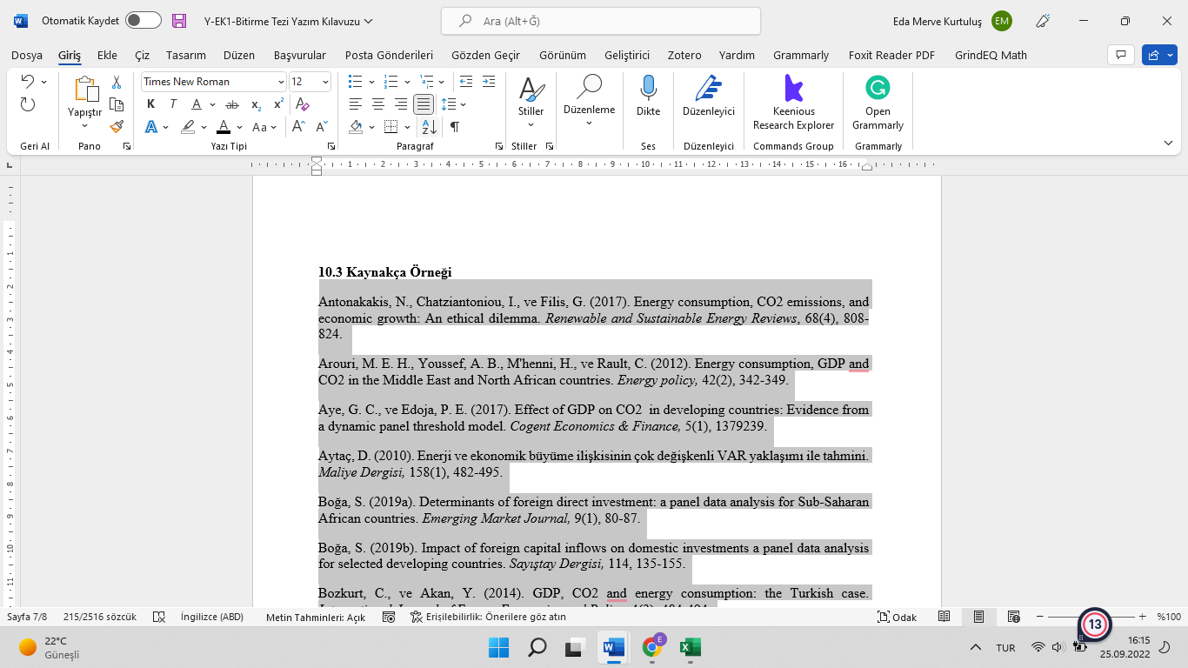

**Figure 3. Sorting of the References**

**Example:**

Antonakakis, N., Chatziantoniou, I., ve Filis, G. (2017). Energy consumption, CO2 emissions, and economic growth: An ethical dilemma. Renewable and Sustainable Energy Reviews, 68(4), 808-824.

Arouri, M. E. H., Youssef, A. B., M'henni, H., ve Rault, C. (2012). Energy consumption, GDP and CO2 in the Middle East and North African countries. Energy policy, 42(2), 342-349.

Aye, G. C., ve Edoja, P. E. (2017). Effect of GDP on CO2 in developing countries: Evidence from a dynamic panel threshold model. Cogent Economics & Finance, 5(1), 1379239.

Aytaç, D. (2010). Enerji ve ekonomik büyüme ilişkisinin çok değişkenli VAR yaklaşımı ile tahmini. Maliye Dergisi, 158(1), 482-495.

Boğa, S. (2019a). Determinants of foreign direct investment: a panel data analysis for Sub-Saharan African countries. Emerging Market Journal, 9(1), 80-87.

Boğa, S. (2019b). Impact of foreign capital inflows on domestic investments a panel data analysis for selected developing countries. Sayıştay Dergisi, 114, 135-155.

Bozkurt, C., ve Akan, Y. (2014). GDP, CO2 and energy consumption: the Turkish case. International Journal of Energy Economics and Policy, 4(3), 484-494.

Erkişi, K. [Kazım]. (2018). Foreign direct investment, trade openness and economic growth: A Case of Turkey. Akademik Hassasiyetler, 5(10), 189-202.

Erkişi, K. [Kemal]. (2018). Financial development and economic growth in BRICS countries and Turkey: A panel data analysis. Istanbul Gelisim University Journal of Social Sciences, 5(2), 1-17.

Erkişi, K. ve Boğa, S. (2019). High-technology products export and economic growth: A Panel Data Analysis for EU-15 countries. Bingöl Üniversitesi Sosyal Bilimler Enstitüsü Dergisi, 9(18), 669-683.

Hastalıklardan Korunurken Yapılması ve Yapılmaması Gerekenler. (2020). Erişim adresi: https://gelisim.edu.tr/duyuru/hastaliklardan-korunma

Kaldor, N. (1957). A model of economic growth. Economic Journal, 67 (268), 591-624.

Lisansüstü Eğitim ve Öğretim Yönetmeliği. (2016, 20 Nisan). Resmi Gazete (Sayı: 29690). Erişim adresi: http://www.resmigazete.gov.tr/eskiler/2016

Luintel, K., Khan, M., Leon, R. ve Li, G. (2016). Financial development, structure and growth: new data, method and results. Journal of International Financial Markets, Institutions and Money, 43, 95-112.

Olağanüstü Hal Kapsamında Bazı Tedbirler Alınması Hakkında Kanun Hükmünde Kararname (2017, 6 Ocak). Resmi Gazete (Sayı: 29940 (Mükerrer)). Erişim adresi: http://www.resmigazete.gov.tr/eskiler/2017/0

Ono, S. (2017). Financial development and economic growth nexus in Russia. Russian Journal of Economics, 3 (3), 321-332.

Para Politikası Üzerine Görüşler (2020). Ankara: T.C Merkez Bankası.

Yapraklı, S. (2007). Ticari ve finansal dışa açıklık ile ekonomik büyüme arasındaki ilişki: Türkiye üzerine bir uygulama. İstanbul Üniversitesi İktisat Fakültesi Ekonometri ve İstatistik Dergisi, (5), 67-89.

1. **SEQUENCING**

**The following sequencing is followed in compiling and binding the thesis.**

**(1) External Cover**

**(2) Blank Page**

**(3) Thesis Introduction Form**

**(4) Inner Cover**

**(5) Declaration**

**(6) Acceptance and Approval Page of the Jury Members**

**(7) Abstract (Turkish and English, consecutively, which do not exceed 2 pages)**

**(8) Table of Content**

**(9) Abbreviations (If any)**

**(10) List of Tables (If any)**

**(11) List of Maps (If any)**

**(12) List of Graphics (If any)**

**(13) List of Figures (If any)**

**(14) Lift of Images (If any)**

**(15) List of Appendixes (If any)**

**(16) Preface**

**(17) Text (Introduction, Chapter, Conclusion)**

**(18) References**

**(19) Appendixes (If any)**

**(20) Resume (Optional)**

**(21) Blank Page**

1. **EXTERNAL COVER**

The outer cover is made of white glossy (Bristol) cardboard. On the cover; Faculty name, original name of the thesis, department, type of thesis, name and surname of the author, name and surname of the advisor, department and program, year and year of publication of the thesis. For the title of the thesis, Times New Roman 16, for other texts Times New Roman 14 font and size bold letters are used. The name of the thesis, the surnames of the author and the thesis advisor are written in capital letters, and all other words are written in lowercase letters with the first letter capitalized.

On the back of the outer cover; When the book is held horizontally, the name of the author, the original name of the thesis and the year of publication are written as described for the cover. However, the font size can be changed depending on the length of the thesis title and the thickness of the book.

tablo içeren bir resim

Açıklama otomatik olarak oluşturuldu

**Figure 4. External Cover and the First Inner Page**

1. **Updating the Table of Contents**

Enter the "REFERENCES" section in the Word tab and click "Update Table". The table in the thesis template will be updated automatically.

**13.** This BEY444-Graduation Thesis Writing Guide enters into force on the approval date of the Faculty of Health Sciences Administrative Board.