Customer options in SecureCenter

Log in and account details
Each institution has their own account in Secure Center. This is set up at the same time as their access is set up. A username and password for SecureCenter will be provided as part of the account set up process.
The URL for Secure Center is http://securecenter.sagepub.com/Account
The details below cover what the customer will see in Secure Center.

Homepage
When logging into Secure Center, the user sees the Account Detail page, below:
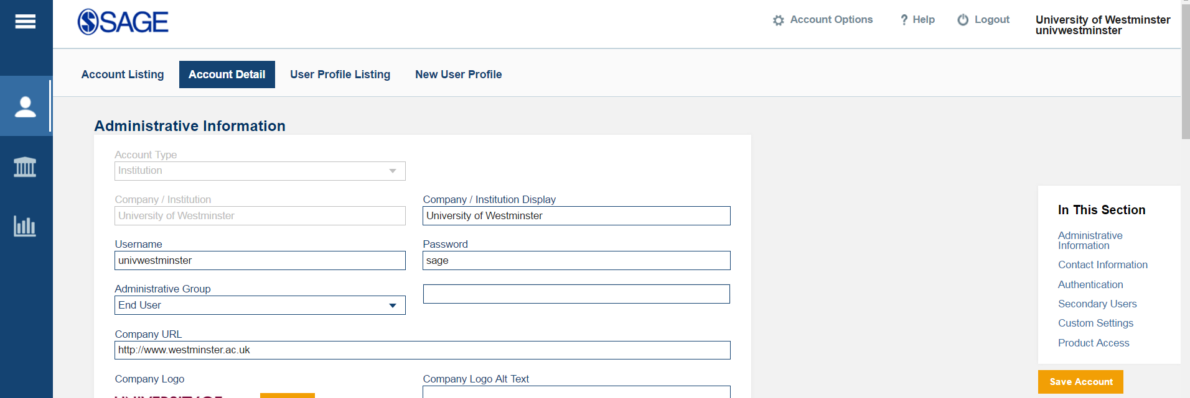
On this page, the administrator has options to:
- Review and edit administrative Information, including username, password, and Open URL resolver.
- Review and edit contact information
- Review IP ranges (only SAGE can edit these)
- Review and edit Athens/Shibboleth details, and referring URLs
- Review and edit Secondary Users (these are usernames and passwords that the institution can set up to grant access to their patrons)
- Review and change custom settings:
  - Option to hide unavailable SAGE content (subscription sensitivity)
  - Option to hide SAGE Recommends
- Review Product Access/Entitlement Pool. This is the books/videos/cases etc that the institution has access to.
- Input a SAGE Business Cases Instructor Verification Code

Platform Details
On the second page, the administrator can see platform details. They can reach this page by toggling to it using the icons on the left hand side, circled in the screengrab below.
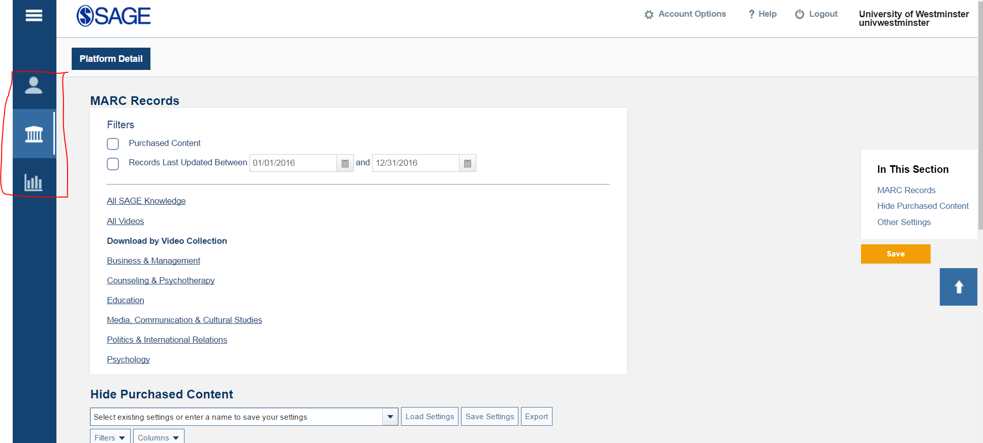
On this page, the administrator can:
- Download MARC records for their acquired content.
- Hide purchased content at a book-by-book level (if they want to make a particular book unavailable once the library has acquired a subsequent edition, for example). This works for Video and Cases as well.
- Hide SAGE Recommends.
- Input a SAGE Business Cases Instructor Verification Code

Usage Reporting
In the third tab, administrators can download usage reporting.
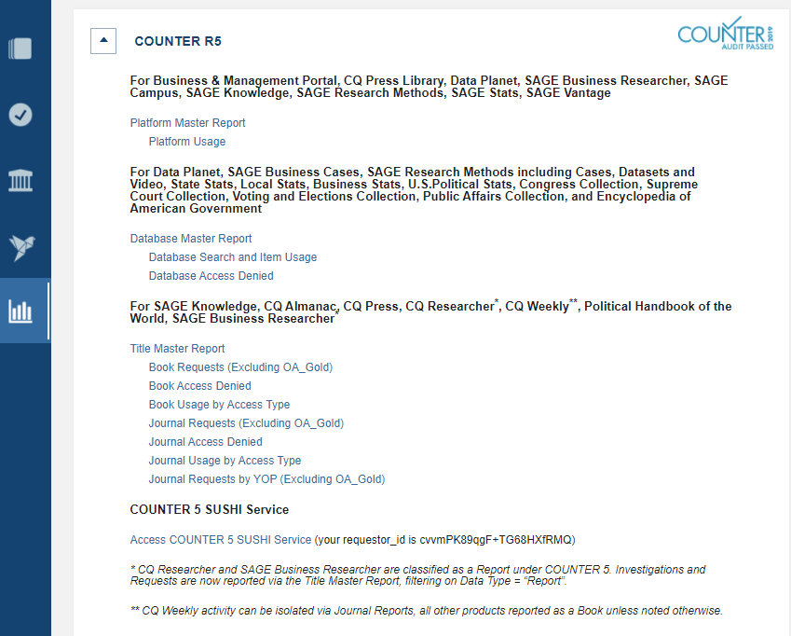

Users have options to:
- Download a range of COUNTER stats for our full suite of products hosted by GVPi
- Review help documentation about COUNTER reporting
- Download Historic Usage data from the previous SAGE Knowledge platform
- Download a number of custom (non-COUNTER) reports
NB – more information about what is available in all these reports can be found in the help docs.

